GEOL 335 (2019/20-02) Homework assignment #5

Instructor: Prof. I. Morozov Due: Apr 6 2020
- (15%) A reflection seismic line is shot at 20-m station (geophone) intervals using a 101-channel recording system and shooting at every 4-th station. Recording is split-spread, with the source always located at the middle of the spread. Give formulas and calculate values for the following:
    - Maximum depth at which the incident and reflection angles reach 30°

  - Mid-point (CMP) spacing

  - Nominal CMP reflection fold

- (20%) Figure below shows a GPR line (grey) planned over a roof of a cellar with 45°slopes. In the same plot, draw in the expected reflections. Assume 1:1 scaling for two-way travel time.
Hint: GPR imaging is the same as shallow seismic with collocates sources and receivers. Imagine that there is a pair of a source and receiver at each point of the grey line. Draw two-way travel reflection time downward from that point.
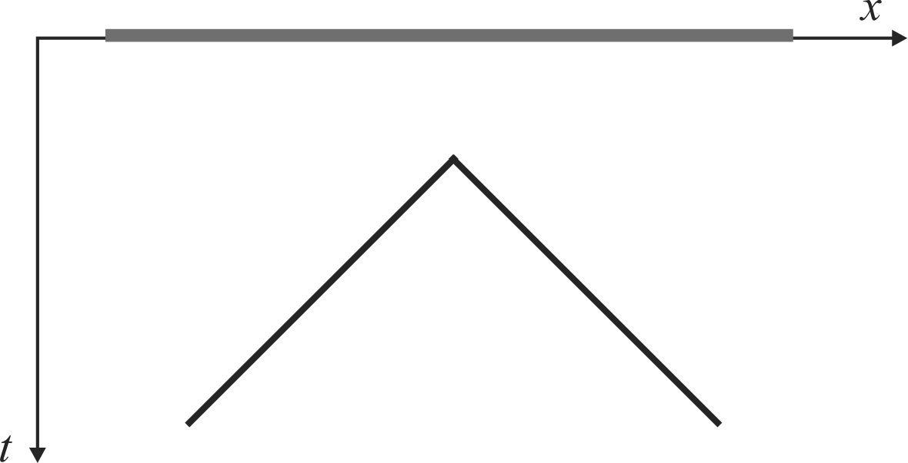
(20%) Show that function 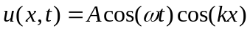satisfies the wave equation if ω = ck, where c is the wave velocity, w = 2πf is the angular frequency and k = 2π/λ is called the wavenumber.
    - Why does not this function have the form of f(t± x/c) discussed in class? Hint: in which direction does this wave propagate?

    - Express the wavefield u(x,t) above in the form of f(t± x/c).

- (20%) Write expressions for the traveltime curves t(x) for refraction SMNPQR and refraction multiple SMNTUWPQR in the plot below. Evaluate numerical values for the parameters of these expressions.
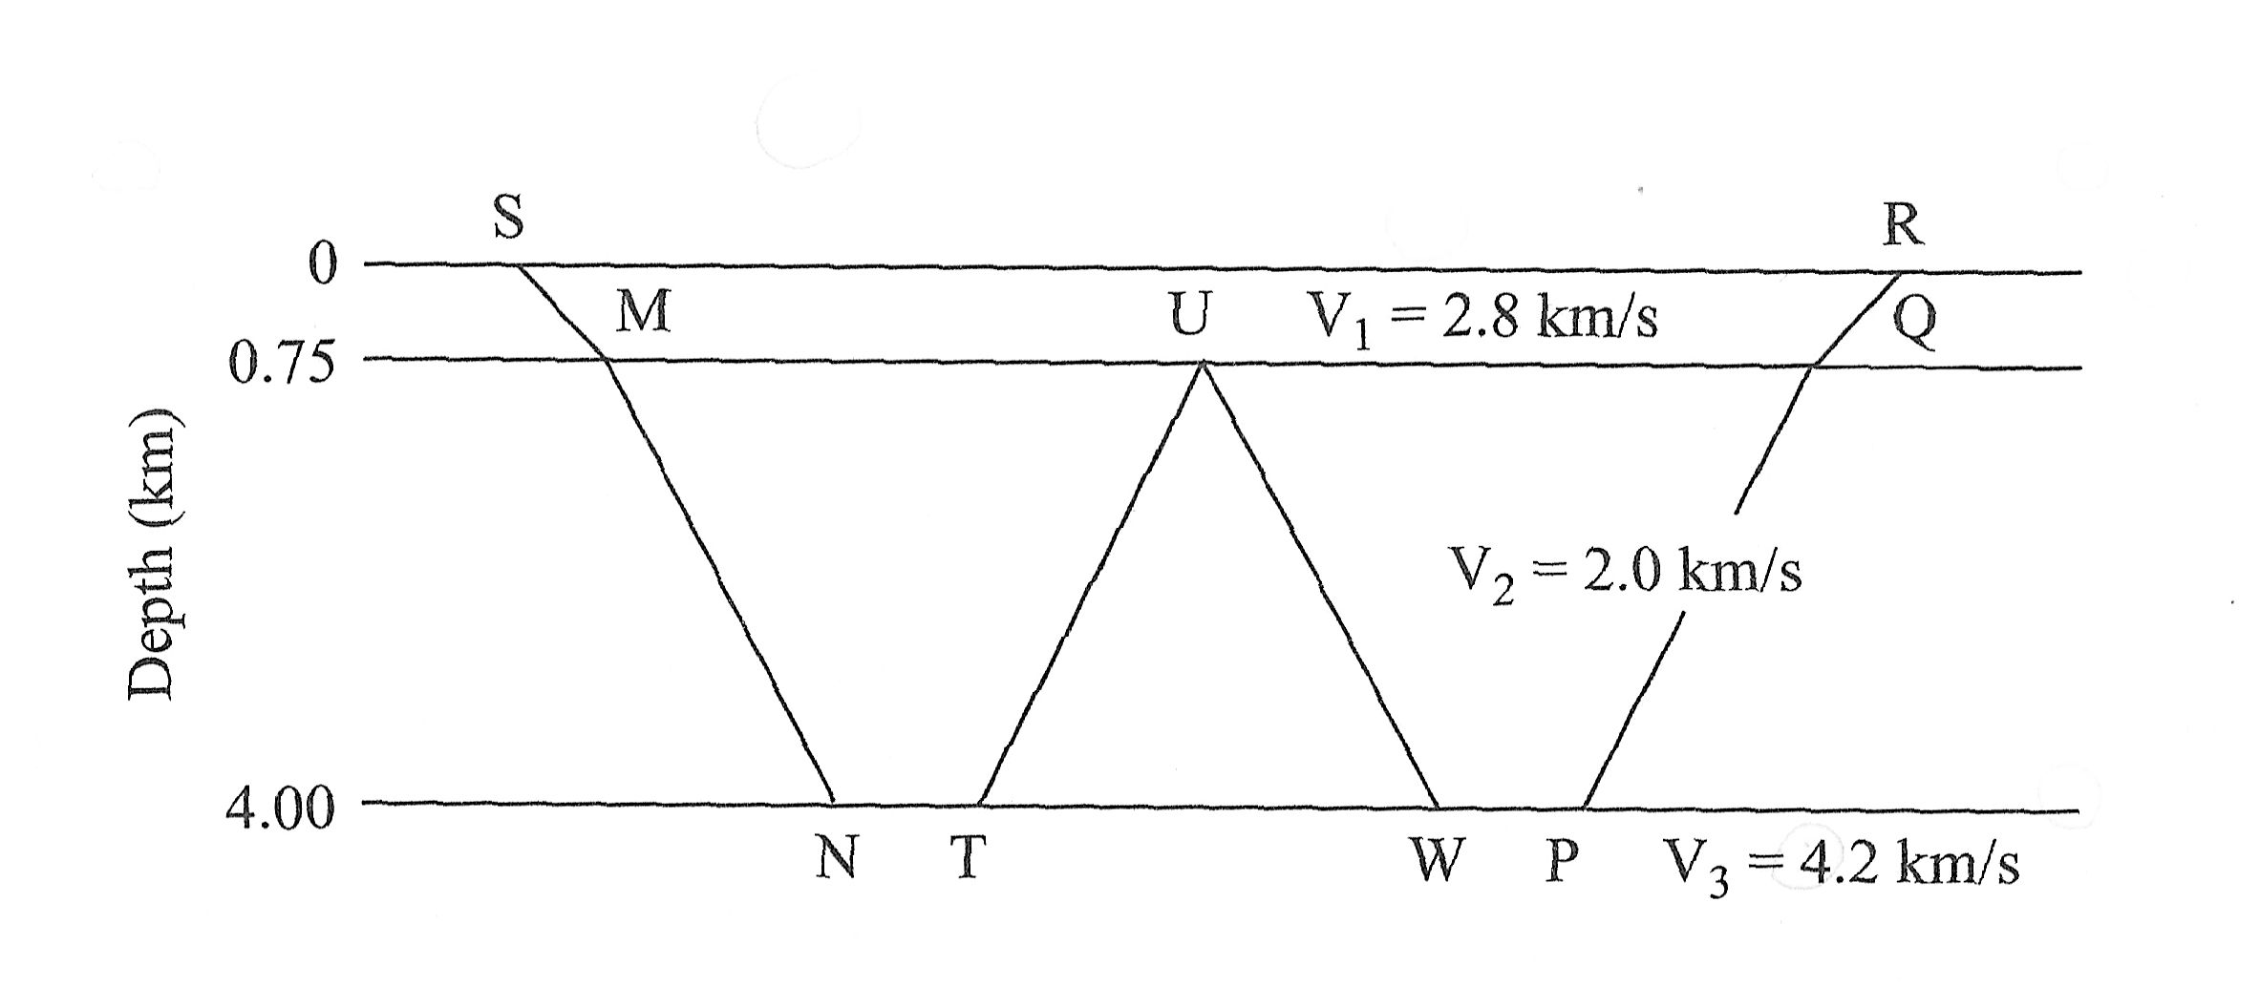

- (25%) Seismic section below shows a primary reflection from the sea floor and four of its multiples recorded in a marine survey (assume that both the source and streamer are at 15-m depth). The water depth is 420 m, the acoustic velocity in water is 1.5 km/s, and the velocity below the sea floor is 2.59 km/s. Water density is 1.03 g/cm³.
Assume that the display has been corrected for geometric spreading, so that seismic amplitudes represent variations of reflection coefficients.
    - In a separate plot, sketch ray paths for the primary reflections and four multiples.
    - The reflection coefficient is highest at the critical angle. From velocities given above, calculate the critical angles and distances for the primary reflection and multiples.
    - On which traces would you expect the largest amplitudes for the primary reflection and each multiple? Is this expectation close to the observation from the plot below?
    - What is the ratio of the amplitudes for successive multiples (from the formula for reflection amplitude from impedance contrast)? Try measuring these ratios from the record. From this, estimate the density below the seafloor.


