GEOL 335 (2021/22-01) Homework assignment #4

Instructor: Prof. I. Morozov Due: Dec 1 2021
- [20%] Illustrate the phenomenon of frequency folding mathematically. To do this, consider sampling rate of f_{s} samples per second and give the expression for the Nyquist frequency f_{N}. Follow this procedure:
  - Write an expression for a harmonic (sine or cosine) function of time at frequency f_{N}+Δf.
  - Consider the values of this function at sampling times, that is, at t_{k} = kΔt (how is Δt related to f_{s} and f_{N}?).
  - Show that the harmonic function taken at sampled times only is equivalent to another one with frequency f_{N} – Δf.

- [20%] Seismic reflections are recorded by receivers planted on the sea floor (Figure below). The ghost reflection from the sea surface acts as a “notch” filter, i.e., filter removing certain frequency from the reflected waves. Derive a formula for this frequency as function of water depth h and ray parameter p.
Hints:
Remember that the reflection from the surface is of negative polarity (changes sign upon reflection).
Write cosine function representing the reflected wave arriving to the geophone on the sea floor the depth: u₁(t) = Acos(2πft), and add reflection of the same wave from water surface: u₁(t) = u₁(t) = -Acos[2πf(t+τ)] . What is the time lag τ between these waves?
For wave cancellation, the sum u₁(t) + u₂(t) must equal zero at all t. At what frequencies f will this cancellation occur? Note that there will be multiple solutions for f.

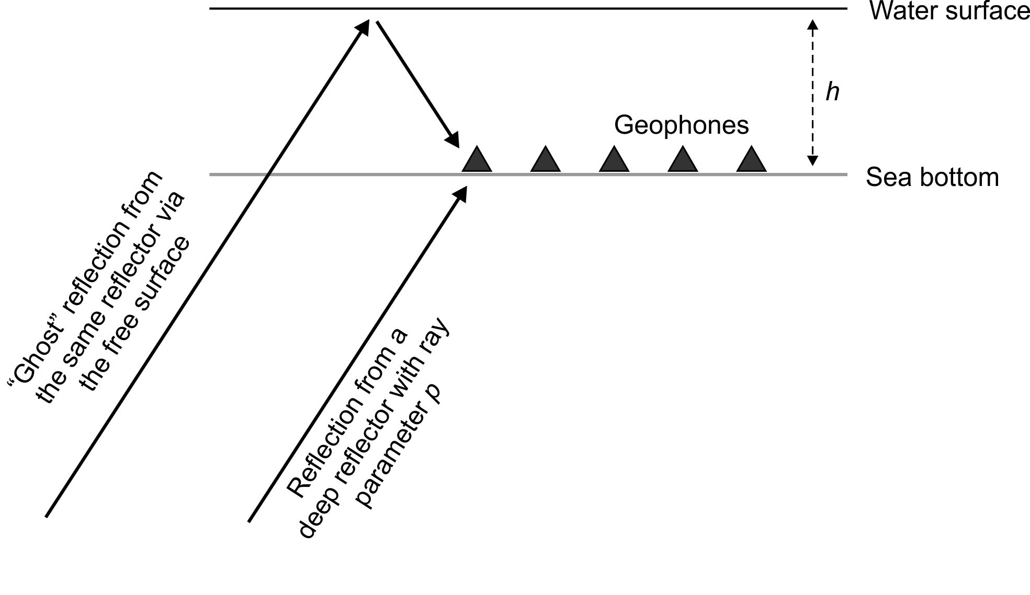

- [20%] Consider two finite time series u = {2,5,-2,1} and v = {6,-1,-1}.
  - Convolve these two series. Do not forget about negative lags.
  - Cross-correlate the same two series. For what lag are these time series most similar?

- [20%] Show that the autocorrelation φ_{u}(k) of time series {u_{k}}, taken at lag samples k = i – j can be given by:
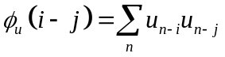

- [20%] The dominant period of marine seismic sources is often determined by the source depth. In this case, the second (negative) half-cycle of the downgoing wave is reinforced by the ghost reflection from the surface. Assuming that this is true for the source signatures shown below, determine their depths. Take V_{W} = 1500 m/s for the acoustic wave velocity in water.
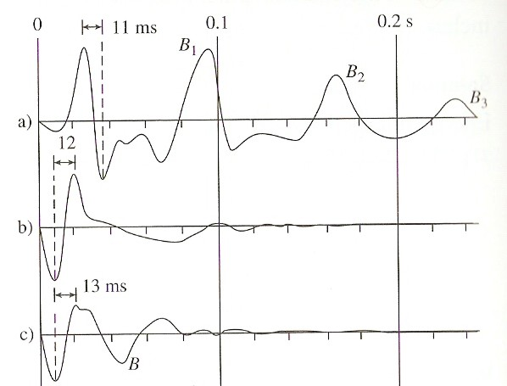
The sources shown here are: a) single 120 cubic inch airgun (B₁, B₂, and B₃ are bubble oscillations); b) array of airguns of different sizes selected to attenuate bubble effects; c) sleeve exploder.

