GEOL 335.3 (2024/25) Homework assignment #1

Instructor: Prof. I. Morozov Due: Feb 3, 2025

- (20%) A plane seismic wave (such as generated by a far-away source) is approaching a cube of very low-velocity material (Figure below). Sketch the wavefronts as they propagate through the low-velocity body. How would the wavefield look as it propagates far to the right?
Hints:
- Try achieving reasonably accurate wavefronts spacings outside and inside the body, as in Lab 1a.
- Start with the areas of faster velocity and use the Huygens principle to construct the wavefronts.
- Determine how the wave will reach point A on the back of the cube faster: through the cube or around its perimeter?
- Think whether there will be any head waves within the slower medium?
- Will there be a contact surface, as in Lab 1a?

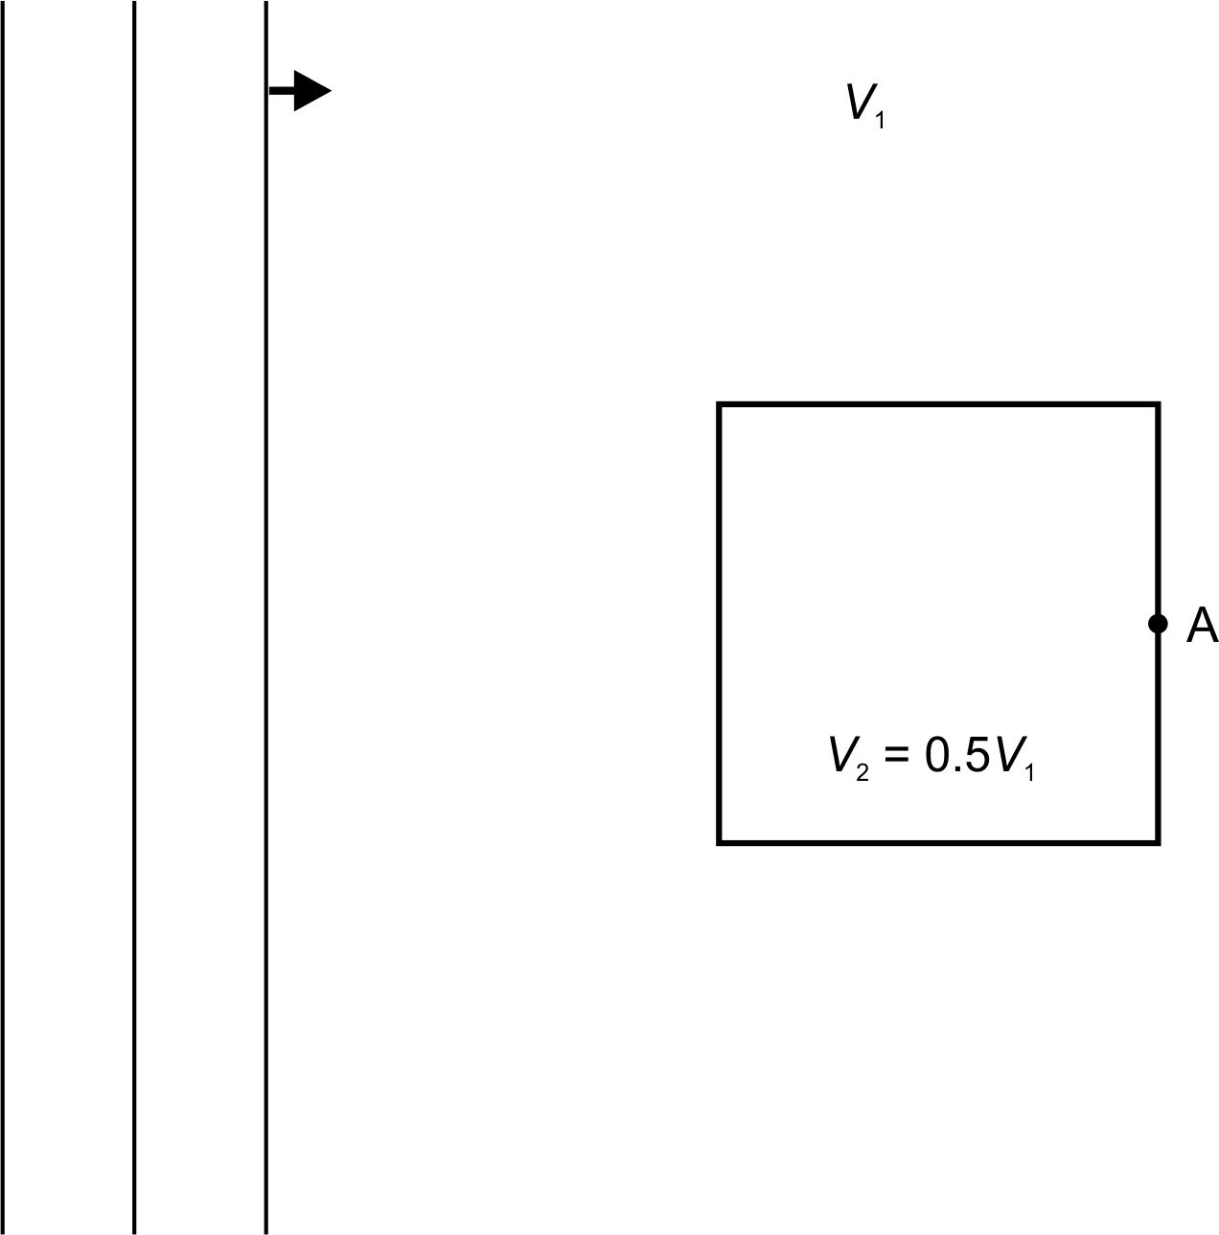
- (20%) The same questions, for a high-velocity cube (note that I suggest shorter intervals between the wavefronts in this case):

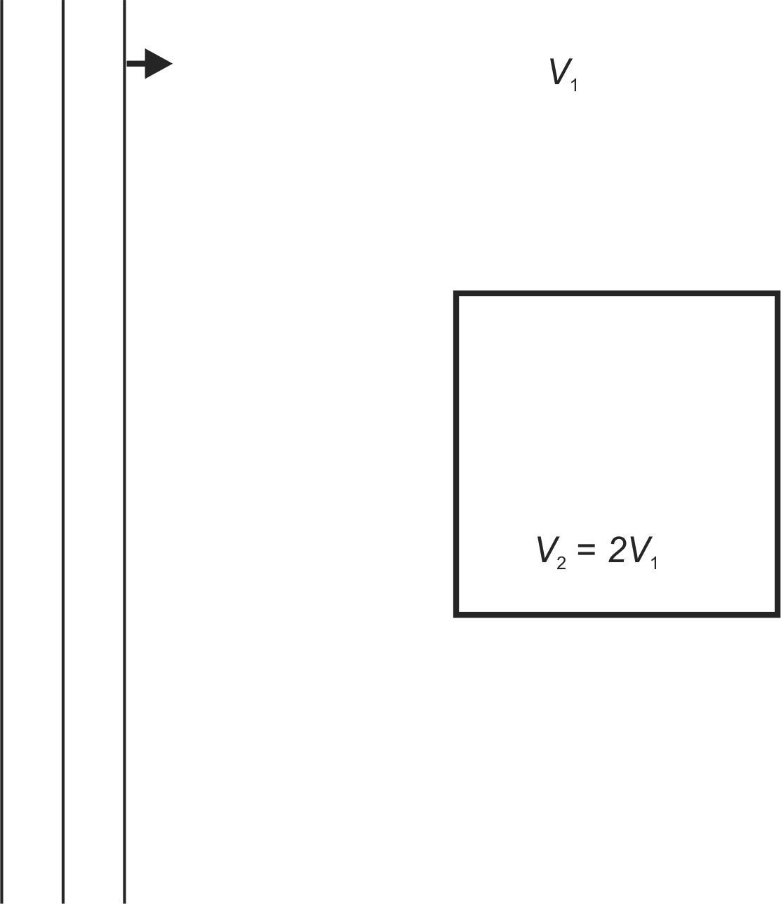

- (10%) Explain the relation/differences between the apparent and true velocities.

- (5% each = 20%) Give definitions for:

  - intercept time,

  - delay time:

  - reciprocal time:

  - ray parameter:

- [15%] You are planning a refraction survey targeting a refractor at about 100-m depth. The expected refractor velocity is 2500 m/s, overburden velocity is 1000 m/s. To what minimum distance from the source should you extend the line? Give the name for this distance, derive the expression, and determine its value.

- [15%] Suppose you have conducted the experiment described in the preceding problem and indeed found the velocities and refractor depth stated there. At what depth can you place a “hidden” layer with velocity 2000 m/s in this model? Explain your answer and illustrate by a sketch of travel times. Hint: compare the times of direct and both head waves at cross-over distance.

