GEOL 335.3 (2024/25-02) Homework assignment #3

Instructor: Prof. I. Morozov Due: March 17, 2025

- A zero-offset (that is, with collocated sources and receivers) reflection line was acquired over a horizontal reflector with a narrow gap of width Δ in it (see figure below). Depth to the reflector is H, velocity of the overburden is V.
  - [10%] In the bottom plot, sketch the resulting reflection section (times of reflections). How does it look above the gap? Use “1:1” time scale, meaning that time t is represented by the same length on the plot as distance x or depth equal Vt/2.
Note that this scale means that a reflection at depth H (at time t = 2H/V) will be plotted at the same Y distance in the time plot as the reflector in the depth plot.
  - [5%] Give an expression for the reflection travel time (label on your section).
  - [5%] If the dominant signal frequency is f, for which values of Δ the gap in the reflector would be detectable? Explain.

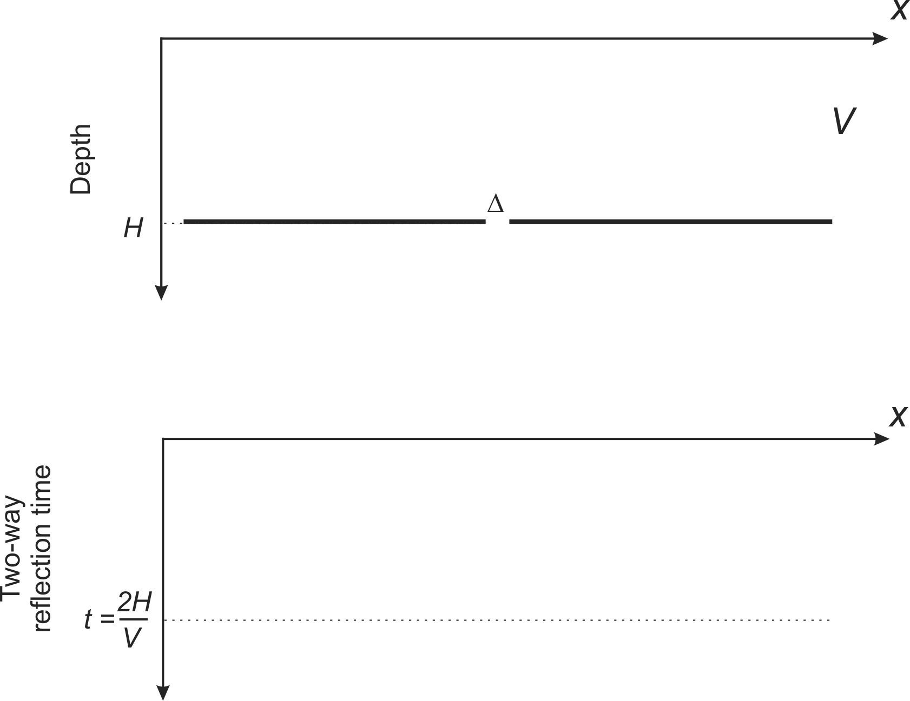

- In problem #1), remove the left half of the reflector and:
  - [10%] In the depth-section (upper) plot, sketch the positions of the wavefront at times t₁=H/V and t₂=2H/V . Assume that at time t=0, the wavefront is at the surface (as if all the surface shots of this CMP line were fired simultaneously at t=0).
Do not forget about the diffractions from point S (edge of the reflector). Use Huygens principle to place the wavefronts.
  - [5%] In the bottom time section plot, sketch the resulting reflection times.
To plot reflection times, consider source-receiver pairs at the surface at points A, B, C, D, and E (or add any other). For each point, draw rays to the reflector and back. Point S will also serve as a reflector (scatterer), and so draw rays to and from it too. Now, how will you draw the travel times for these rays in the bottom plot? Connect these points to obtain graphs of reflections. What are the slopes of the diffraction far away from point S?

- 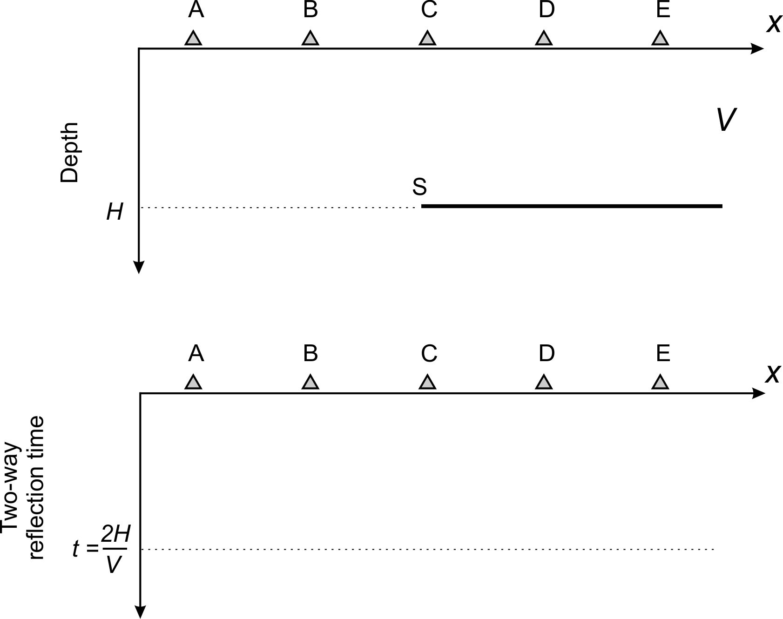
3) [10%] In plot below, bold lines represent a reflector with a sharp bend at point S. Using 1:1 time/distance scaling (see problem 1), sketch the image of the reflector in the time section.

As before, do not forget about diffractions from point S. To plot, draw rays from each of the points A, B, C, and D (or other) to the reflector and to the scatterer S. Then graph the two-way travel times for these reflections in the bottom plot.

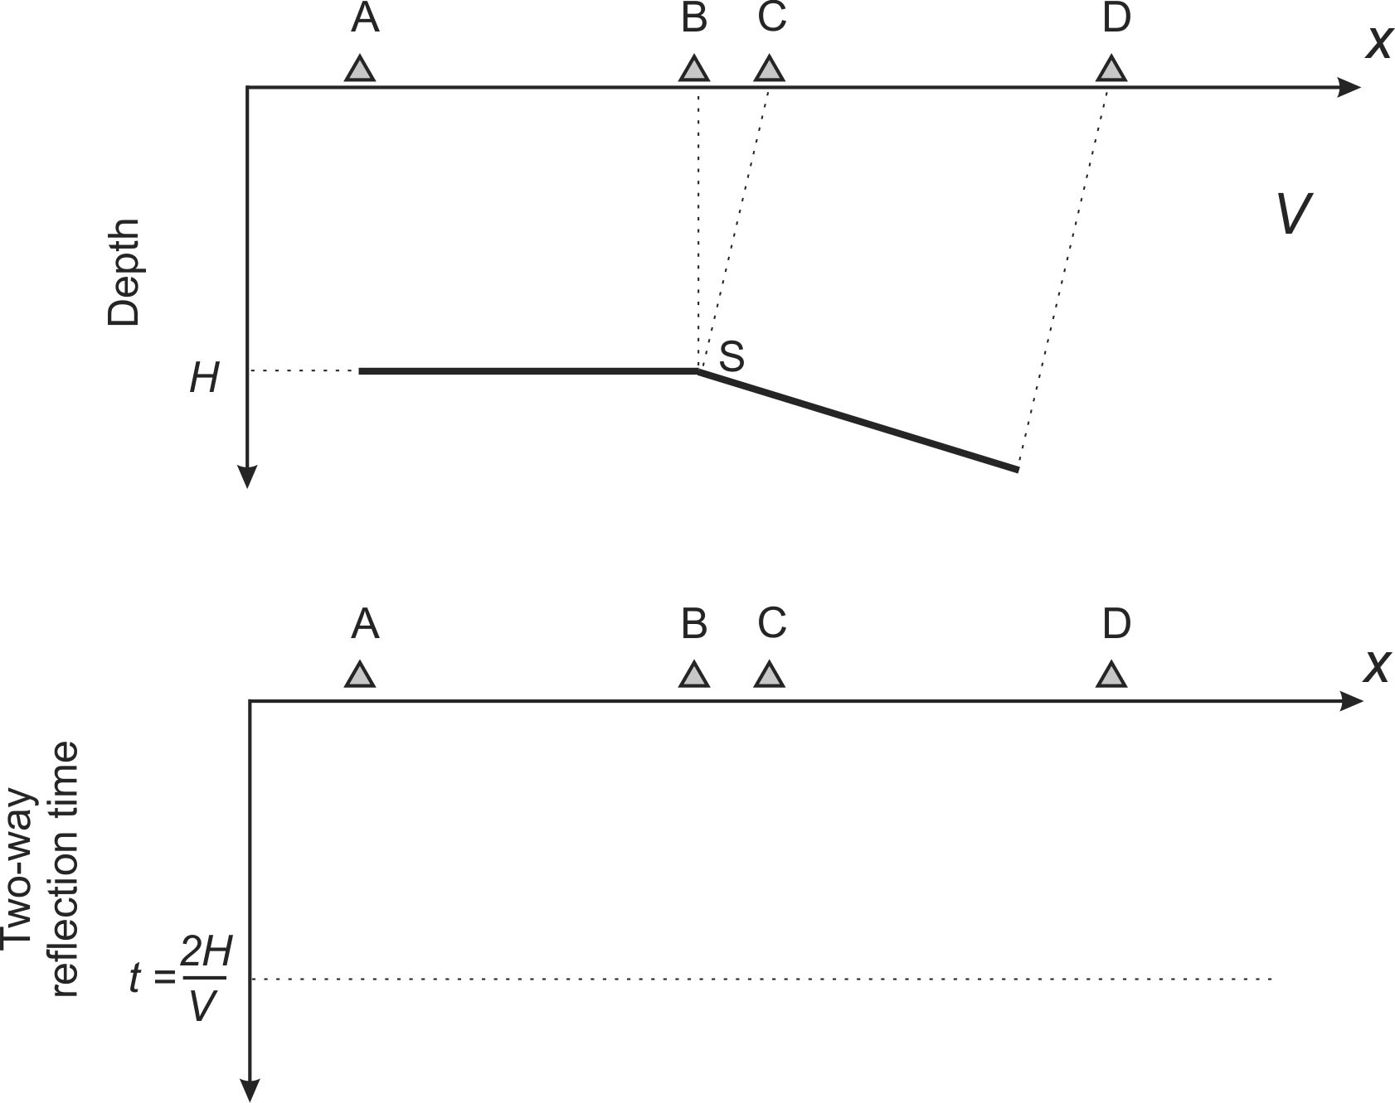
4) [15%] Assume a single point scatterer (small body with a velocity/density contrast; for example, an ore body) at depth H below the surface. The wave speed is V.
  - For an expanding source-receiver spread with its midpoint centred over the scatterer, derive an equation for two-wave reflection travel time as a function of the source-receiver distance, t(x). Is it different from the NMO curve for a plane reflector?

  - Now assume you are looking at a zero-offset reflection section. The scatterer will also produce a diffraction hyperbola in this section. Derive its formula, t(x), as a function of the horizontal distance x from the scatterer’s projection on the surface. How is it different from the NMO curve above? Sketch the two curves in the same plot.

5) Assume horizontal layering as shown below, with a shot (star) near the surface (boundary A).
  - [5%] Determine the RMS velocity for reflector C
  - [5%] For a ray with ray parameter p = 0.25 s/km, what are the angles of its incidence on reflectors B and C?
  - [5%] For this ray, determine the surface location (distance from the surface projection of the shot) at which this ray will be recorded and the travel time.
  - [5%] Calculate the difference of the travel time predicted by the exact formula (question c) and from the RMS approximation (question a; see lecture notes and texts). What is the relative error of this travel time?
  - [10%] At what signal frequency will the time error introduced by the approximate NMO correction in the preceding question cause signal distortion? Hint: the time error will be unacceptable if it exceeds half of the wave period.

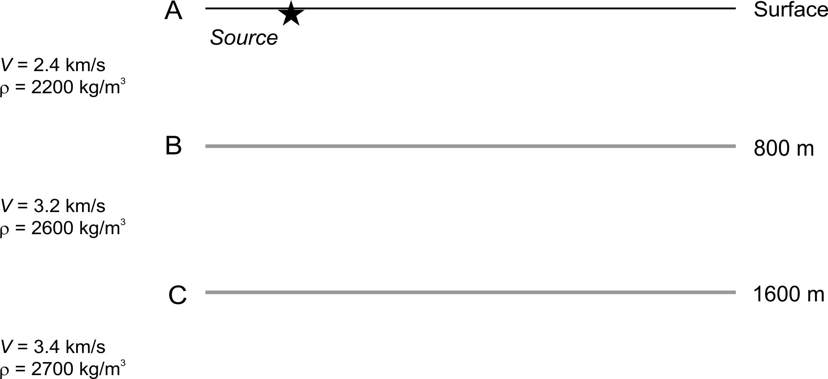

6) [10%] A linear Common Mid-Point (CMP) reflection survey contains N_{S}=1000 shots and is conducted using a cable with N=192 geophone groups. Shots are carried out at every k = 3rd geophone location, and the cable is moved with every shot.

a) Give the formula for the nominal CMP fold in terms of N and k and calculate its value.

b) What is the ”receiver fold” (nominal number of records collected at one receiver location)?

