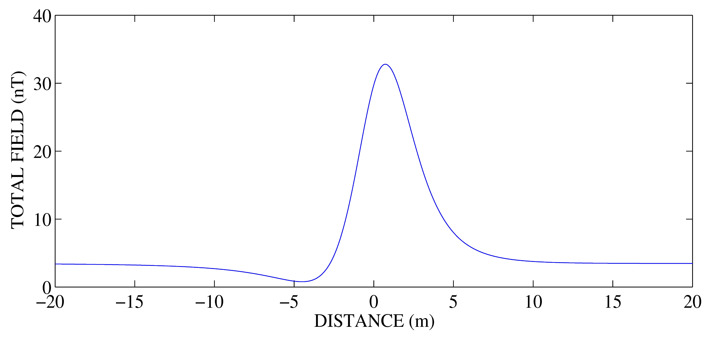
Fig. 1.1 Use Peters slope method
Fig. 1.2 Use Linear Slope method

Fig. 1.3 Use Sokolov’s method
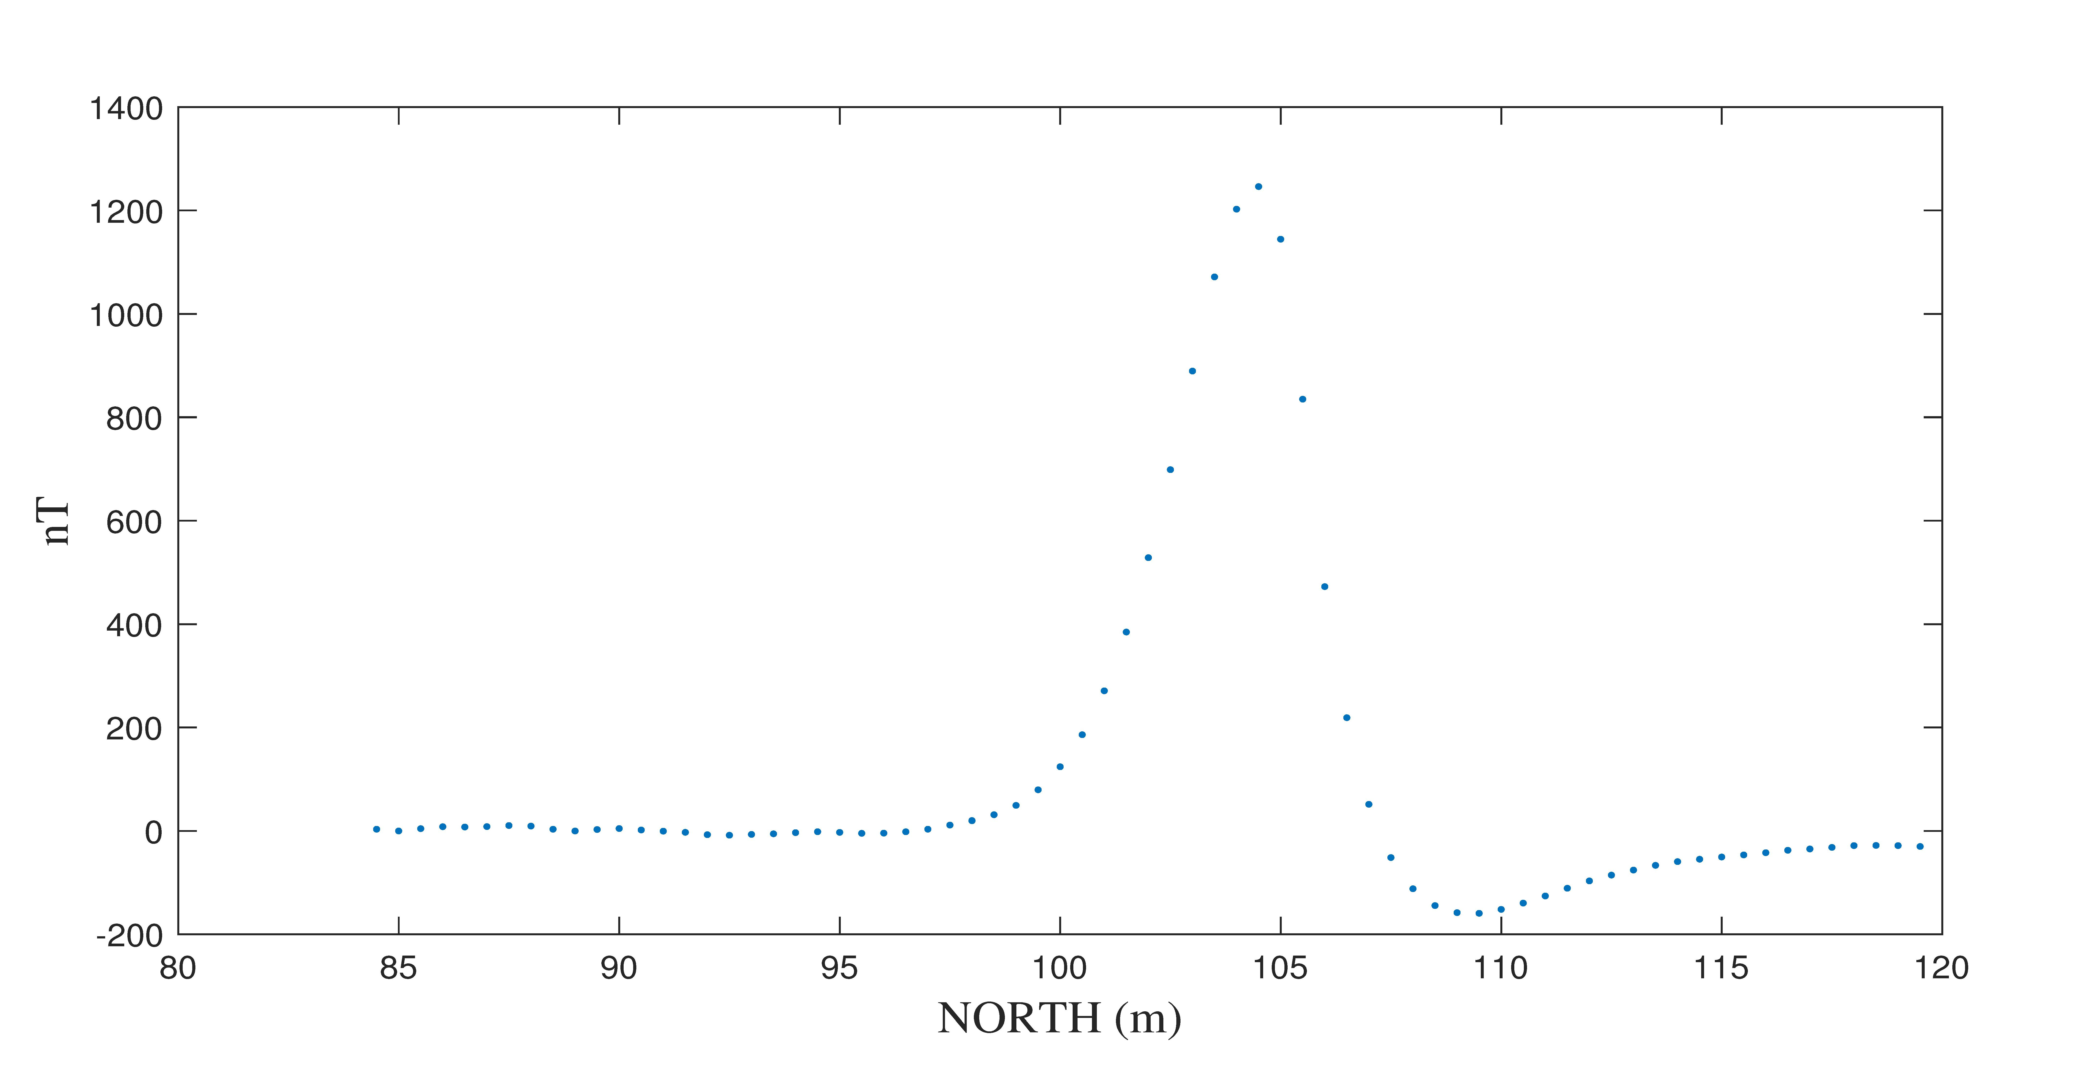
Fig. 2.1 Use E-line method

Fig. 2.2 Use Werner’s method
Fig. 2.3 Use Logachev’s method
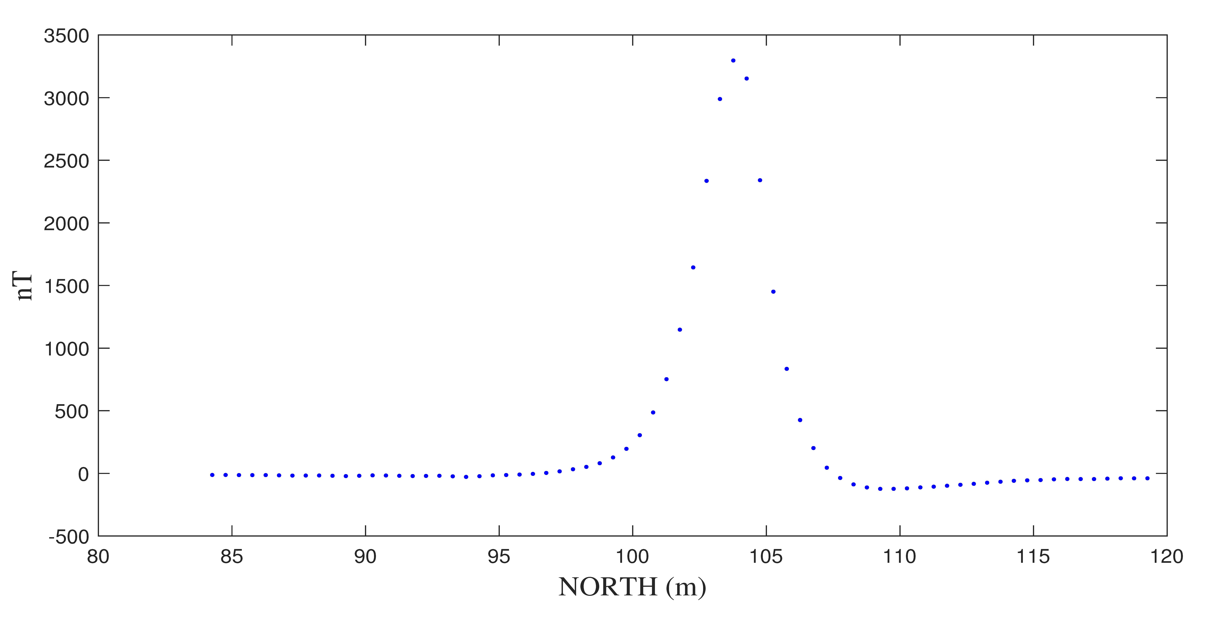
Fig. 3. Use E-line method and compare to Fig. 2.1

Fig. 4.

